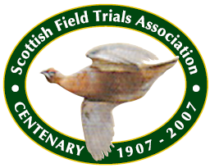
Scottish Field Trials Association
I.D. NO – 387 (Sponsored by RED MILLS)

2023 SPRING GROUSE TRIALS FOR POINTERS AND SETTERS
(To be held under K.C. Rules and Regulations)
JUDGES : MR COLIN ADAMSON(186)AND MR PAUL DALE(3655)
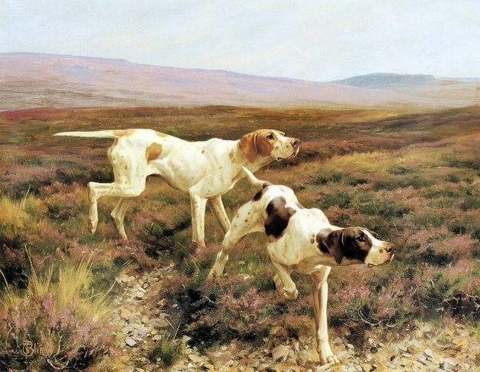
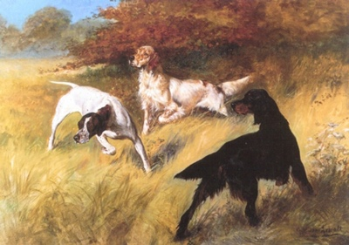
To be held at DALMIGARRY ESTATE, INVERNESSHIRE
(by kind permission of Dalmigarry Estates)

KEEPER OF THE BEAT: ALLAN HODGSON ESQ
STEWARD OF THE BEAT: JON KEAN ESQ

ORDER OF STAKES
FRIDAY, MARCH 31,2023
STAKE 1 - OPEN STAKE. Open Stake (Qualifying). For Pointers and Setters of any age. This stake will be limited to 40 dogs.
Preference in the draw will be given in the following order:-
1. Members dogs which have gained a 1st, 2nd or 3rd Award in an Open Stake or a 1st or two 2nd Awards in other Stakes.
2. Non - Members dogs which have gained a 1st, 2nd or 3rd Award in an Open Stake or a 1st or two 2nd Awards in other Stakes.
3. Members dogs which have gained other Awards.
4. Non - members dogs which have gained other Awards.
5. Other dogs.
The foregoing Awards must have been gained in a Stake qualifying for entry in the Kennel Club Stud Book and must be stated on the entry form.

SATURDAY, APRIL 1ST,2023
STAKE 2 - NOVICE STAKE. For Pointers and Setters that have not won a 1st, 2nd, or 3rd Prize in Open Stakes or a 1st or two 2nds in other Stakes. Stake 2 will be limited to 45 dogs in total.
NB. In the event of oversubscription, please indicate your preference on the entry form, if entering more than one dog in either stake.

Headquarters: TIRRIEMORE, LOCHINDORB (TEL: 07525 208236)

The Meet: 1 mile North of Tomatin on the A9, follow the Field Trial signs to Dalmigarry Estate,
GPS NH7849932214. Trial commences at 9 am sharp both days. The Draw will take place at 7.30 pm at Tirriemore, Lochindorb, on the evening prior to the Stakes.

PRIZE MONEY (both stakes): 1ST - £40, 2ND - £30, 3RD - £20

The Promoting Club accepts no responsibility for injury, loss or damage to person or property however occasioned. The Association reserves the right to refuse entries. Should circumstances so dictate, the Association, in consultation with the judges, may alter arrangements as necessary. In the event of the Trial being cancelled, £2 of the entry fee will be refunded. No substitutions accepted under any circumstances while reserves stand.

Entries must reach:
JON KEAN, EVERSLEY HOUSE, REDDING ROAD, FALKIRK, FK2 9TY
Tel: 01324 713749. Mobile: 07525 208236.
By WEDNESDAY MARCH 1sr,2023
ENTRY FEES: Members £20 Non - Members £30 (Separate cheques for each entry)

N.B. K.C. Registration Numbers must be included on entry form.
Competitors are requested to include either a SAE or e-mail address to receive the result of the ballot, should the trial be oversubscribed.

Please read the following information carefully

Dogs entered at Kennel Club Ltd licensed Field Trials must be registered at the Kennel Club Ltd in accordance with Kennel Club Ltd Regulations for Classification and Registration B.
All dogs resident outside the UK must be issued with a Kennel Club Ltd Authority to Compete number before entry to the
Field Trial can be made. All overseas entries without an Authority to Compete number will be returned to the
Competitor.
Joint owners of dogs must both/all be members of the Scottish Field Trials Association.
Entry Form: Please complete your entry form in legible block capitals, ensuring that you include Awards gained. Incorrect entry forms will not be placed in the Draw.

Entry Fees: If paying by cheque, a separate cheque is required for each entry. Fees must accompany entries.
Ownership: When a dog is in joint ownership, all owners must be members of the Association to qualify for Members’ preference in the draw for the Open Stake. Please ensure that details of ownership are correct. If the dog is owned in partnership, all owners must be named. Incorrect details could result in a Kennel Club fine. If you have applied to The Kennel Club for transfer of ownership, please write TAF (transfer applied for) after the dog’s name.

Multiple Entries: Where an individual enters more than one dog in a stake, he/she must nominate his/her first choice.
Stud Book Number: Please use a Stud Book number where appropriate in place of Registration number.
Ballot: If entries or nominations exceed the number of permitted runners, the right to compete shall be decided by
ballot.
Substitution of Dogs: The Association does not permit substitution of dogs while reserves stand. The Association reserves the right to refuse entries.
Cancelled Trial: In the event of a trial being cancelled, the sum of £2 will be refunded.
Should circumstances so dictate, the Society, in consultation with the Judges, may alter arrangements as necessary. Such
changes and the circumstances surrounding them must be reported to the Kennel Club at the earliest opportunity.
No modification will be made to this Schedule except by permission of the Kennel Club, followed by advertisement in
appropriate journals if time permits before the closing of entries.
Judges at a Trial are prohibited from entering a dog which is recorded in their ownership or part ownership.
All competitors and spectators attending the trial must consider themselves under the orders of the officials .
Videography and photography will only be permitted with the express permission of the Chief Steward and the host.
Trophy holders please ensure that clean trophies are returned in time for the trial.

~~~~~~~~~~~~~~~~~~~~~~~~~~~~~~~~~~~~~~~~~~~~~~~~~~~~~~~
WELFARE OF DOGS
Competitors whose dogs are entered at a Kennel Club licensed event should take all reasonable steps to ensure that the needs of their dogs are met and should not knowingly put their dogs’ health and welfare at risk by any action, default, omission or otherwise. A breech of this Regulation may be referred to the General Committee for disciplinary action under Kennel Club Ltd Rules and Regulations.

