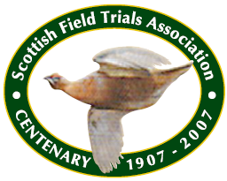

SCOTTISH FIELD TRIALS ASSOCIATION (ID 387)

FIELD TRIALS FOR POINTERS AND SETTERS SUMMER 2021
Held under Kennel Club Limited Rules and Field Trial Regulations

to be held at Tollishill, Lauder by gracious permission of The Duke of Northumberland

Kindly sponsored by

SATURDAY 31 JULY
STAKE 1 PUPPY STAKE for dogs under two years of age on 31 July 2021
As defined in KC Ltd Regulation J.3d(4)
STAKE 2 NOVICE STAKE
As defined in KC Ltd Regulation J.3d(3)
STAKES 1 and 2 Limited to 45 entries in total

SUNDAY 1 AUGUST
STAKE 3 OPEN QUALIFYING STAKE FOR 40 POINTERS AND SETTERS
As defined in KC Ltd Regulation J.3d(1)
Preference in the draw will be as defined in KC Ltd Regulation J.7i(3)
FOR ALL STAKES
Covid Safety Officer Mr Jon Kean
Judges Mr Wilson Young(1790) Mr Bob Whitworth(3165)
Entry Fee Members £15 per entry Non-Members £25 per entry
Prize Money First £40 Second £30 Third £20
Entries Close THURSDAY JULY 1, 2021
Draw THE DRAW WILL BE ANNOUNCED AT THE MEET.
Meet 9AM AT PICNIC AREA AT TOLLISHILL. POSTCODE TD2 6RE. (Vehicles to be
parked with sufficient spacing to ensure social distancing).
Headquarters Carfraemill Hotel, Lauder, Berwickshire TD2 6RA

Please provide a large stamped addressed envelope or email address for the result of the Draw should the trial be oversubscribed.

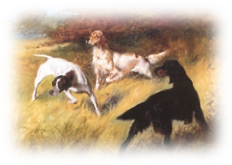

Entries to:
Mr Jon Kean
Eversley House
Redding Road
Falkirk FK2 9TY
Mobile: 07525 208236
jonkean@hotmail.co.uk

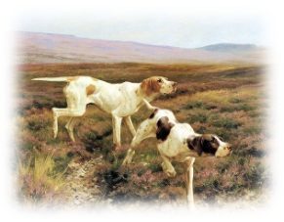

Please read the following information carefully

COVID COMPLIANCE/GENERAL INFORMATION
- A few days prior to the trials, we would request that all competitors make themselves familiar with the Covid 19 requirements in Scotland by visiting the Scottish Government website www.gov.scot.
- At the trial, competitors will wear a mask when in close proximity to each other. Competitors to provide their own face masks and hand sanitisers .
- All entries to be paid in advance (no cash will be accepted on the day).
- If a competitor or anyone in their household has tested positive for Covid 19 or displays symptoms they MUST NOT attend the event and should self-isolate in line with Government advice.
- Catalogues will be provided on the day in a sanitised sealed bag.
- No armbands are permitted.
- No spectators will be allowed on the trial ground.
- Competitors residing in an area covered by a local lockdown enforced by the Government, must not attend the trial.
- Competitors to travel in their own vehicles – no sharing permitted, unless members of the same household.
- Prize cards and prize money will be posted out after the field trial circuit.

Dogs entered at Kennel Club Ltd licensed Field Trials must be registered at the Kennel Club Ltd in accordance with Kennel Club Ltd Regulations for Classification and Registration B.
All dogs resident outside the UK must be issued with a Kennel Club Ltd Authority to Compete number before entry to the
Field Trial can be made. All overseas entries without an Authority to Compete number will be returned to the
Competitor.
Joint owners of dogs must both/all be members of the Scottish Field Trials Association.
Entry Form: Please complete your entry form in legible block capitals, ensuring that you include Awards gained. Incorrect entry forms will not be placed in the Draw.

Entry Fees: If paying by cheque, a separate cheque is required for each entry. Fees must accompany entries.
Ownership: When a dog is in joint ownership, all owners must be members of the Association to qualify for Members’ preference in the draw for the Open Stake. Please ensure that details of ownership are correct. If the dog is owned in partnership, all owners must be named. Incorrect details could result in a Kennel Club fine. If you have applied to The
Kennel Club for transfer of ownership, please write TAF (transfer applied for) after the dog’s name.
Multiple Entries: Where an individual enters more than one dog in a stake, he/she must nominate his/her first choice.
Stud Book Number: Please use a Stud Book number where appropriate in place of Registration number.
Ballot: If entries or nominations exceed the number of permitted runners, the right to compete shall be decided by
ballot.
Return of Entry Fees: Kennel Club Ltd rule J7.f applies.
Substitution of Dogs: The Association does not permit substitution of dogs while reserves stand. The Association reserves the right to refuse entries.
Cancelled Trial: In the event of a trial being cancelled, the sum of £2 will be refunded.
Should circumstances so dictate, the Society, in consultation with the Judges, may alter arrangements as necessary. Such
changes and the circumstances surrounding them must be reported to the Kennel Club at the earliest opportunity.
No modification will be made to this Schedule except by permission of the Kennel Club, followed by advertisement in
appropriate journals if time permits before the closing of entries.
Judges at a Trial are prohibited from entering a dog which is recorded in their ownership or part ownership.
All competitors and spectators attending the trial must consider themselves under the orders of the officials .
Videography and photography will only be permitted with the express permission of the Chief Steward and the host.
Trophy holders please ensure that clean trophies are returned in time for the trial.
~~~~~~~~~~~~~~~~~~~~~~~~~~~~~~~~~~~~~~~~~~~~~~~~~~~~~~~
WELFARE OF DOGS
Competitors whose dogs are entered at a Kennel Club licensed event should take all reasonable steps to ensure that the needs of their dogs are met and should not knowingly put their dogs’ health and welfare at risk by any action, default, omission or otherwise. A breech of this Regulation may be referred to the General Committee for disciplinary action under Kennel Club Ltd Rules and Regulations.

